Year 3/4

Who lived in England 1500 years ago?

Autumn Term 1

In Modern Foreign Languages, we will…

Mrs Leon will help us celebrate European Day of Languages (26th September.) We will also learn autumn colours, harvest and vegetables and commands and actions.

In Reading, we will…

Using the VIPER approach and our vehicle texts to develop reading comprehension skills.

In Religious Education, we will…

Be learning about the religions: Christianity and Hinduism.

In Art and Design, we will…

(Autumn 2)

In PE, we will…

Be focussing on Symmetrical and asymmetrical movements in gymnastics.

Curriculum Enhancements

Forest School

Commando Joes

Well-Being Sessions

School and Class Worship

In Science, we will…

Be learning about animals and skeletons. We will be looking at owls, animal diets, human skeletons and muscles.

In PSHE, we will…

Discuss and explore emotions in different situations as we complete the unit ‘Myself & My Relationships’

In Computing, we will…

Be using stop animation to create animations and make pictures move, bringing drawings to life!

In Design and Technology, we will…

Be using learning how to sew and making money containers based on those from the Anglo-Saxon era.

In History, we will…

Be learning about The Anglo-Saxons. We will be looking at who they were, why they settled in Britain and other details about the lives that they led.

In Writing, we will…

Use our vehicle texts to inform and develop writing tools within haiku poetry and narrative – stories that raise issues.

In Maths, we will…

Developing our knowledge and understanding of place value, addition/subtraction and multiplication and division.

In Geography, we will…

(Autumn 2)

In Music, we will…

(Autumn 2)

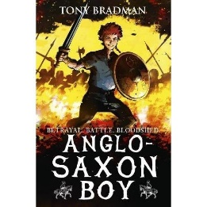

Vehicle Texts



