This policy belongs to
St. Lawrence CE Primary School
Part of the Tibberton CE and St Lawrence CE Primary School Federation

Collective Worship Policy

Revised: Autumn Term 2022
Consultation with Staff & Governors
and adoption of policy: Spring Term 2022
Review Date: Autumn Term 2024

Collective Worship Policy 2022

Introduction
Worship is…
Giving honour and reverence to a supreme being.
Christian worship is concerned with bringing praise, prayer,
thanksgiving and adoration to God.
It is an activity of response: in words, actions and thoughts.
Collective worship plays a central part in the life of St. Lawrence. Collective worship is a means by which the school’s Christian vision is expressed (Strand 6 SIAMS 2018). As an expression of the Christian vision, ethos and spiritual life of the school it offers the whole school community opportunities to experience and participate in whilst taking responsibility for the living expression of Christian worship, valued and honoured through the school’s Anglican Foundation. This is set within the context of the corporate community of our school and its historic partnership with St. Lawrence’s Church set in the heart of the village of Preston-upon-the-weald -moors. We affirm every individual’s unique contribution, regardless of age, gender, sexuality, ability, background or religion.
Legal requirements:
Trust Deed
Our daily act of collective worship is in accordance with the Trust Deed of the school. This requires worship to be consistent with the faith, principles and practices of the Church of England.
DfE guidance
We also take into account DfES legislation. The following link will take you to the current legislation. https://www.gov.uk/government/publications/collective-worship-in-schools
1988 Education Act
We also take into account the 1988 Education that states,
‘…..all pupils in attendance at a maintained school shall in each school day take part in an act of collective worship’.
Section 48 Statutory Inspection of Anglican & Methodist Schools (SIAMS)
All church schools, whether they are Voluntary Aided (VA), Voluntary Controlled (VC) or Foundation (F) will be inspected on collective worship and the impact this has on the whole school community (Strand 6 of the SIAMS 2018 schedule). The core question of this strand is the ways in which collective worship is an expression of the school’s Christian vision. Through our Motto, Vision and Implementation and carefully chosen Christian Core Values we will ensure that Collective Worship is central to all that we do.

Our School Motto
“Being the best we can be, because with God all things are possible”

Vision & Intent
Together, through ‘The St Lawrence Way’ we will embrace the love of learning, be curious of, and be inspired by the endless possibilities that our wonderful world can offer.
Our Core Christian Values
Through our core Christian values, we want to ensure that our school is a place that enables children to learn and play, feel safe, happy and feel valued, where they are able to flourish and experience God’s wonderful world in all its fullness. We aim to provide rich, memorable learning experiences which build character in each individual child. Strong relationships underpin all we do where we value and respect each other’s uniqueness. We provide the space for all children to flourish and be the best they can be. Our Christian ethos nurtures personal beliefs and attitudes, which enables all to seek meaning through life’s journey.
The values that we have chosen to reflect our ethos are:
Respect – Do to others as you would have them do to you. (Matthew 7 v12)
Honesty – The Lord dislikes lying lips but delights in people who are honest and trustworthy. (Proverbs 12 v22)
Courage - Be strong and courageous, do not be frightened or dismayed, for the Lord your God is with you wherever you go. (Joshua 1 v9)
Compassion – Clothe yourselves with compassion, kindness, humility, gentleness and patience. (Colossians 3 v12).
Forgiveness – Just as the Lord has forgiven you so you must also forgive others. (Colossians 3 v13)
Thankfulness – Let them give thanks to the Lord for his unfailing love and wonderful deeds for mankind. (Psalm 107:21)

Our Mission and Implementation
Through the ‘St. Lawrence Way’ we will…..
• Design a curriculum that: recognises children’s prior learning, providing first-hand learning experiences, allowing the children to build resilience and become creative, critical thinkers who have the courage to become lifelong learners fulfil their aspirations.

• Recognise every child as a unique individual. We teach the children to be tolerant of one another whilst understanding and respecting difference and diversity, knowing that all have been created in the image of God.

• Help pupils and adults to develop lifelong learning habits so that they can contribute successfully to their local community and navigate an increasingly complex national and global community so that they recognise their place in the world and show thankfulness.

• Foster a Christian community whereby everyone feels valued and has a strong sense of belonging building upon strong, caring relationships that are based on mutual respect; demonstrated through courtesy, forgiveness and reconciliation.

• Value the community to which we belong by listening, being honest with each other, and creating opportunities for the pupil voice to be heard, which will support good mental health and the wellbeing for all.

• Instil core Christian values through our collective acts of worship by trusting our children to make positive choices and show compassion towards others, supporting the strong moral sense of right and wrong, which will have a positive impact on pupils’ outcomes and behaviour.

Our School Aims

- To promote the joy of worship as engaging, inspiring and transformative.
- To develop spirituality, morality, social and cultural values.
- Provide opportunities to create a peaceful environment enabling stillness, reflection and prayer.
- Plan occasions where we can be joyous with singing, music, dance, drama in celebration.
- To give an opportunity to experience faith as revealed in the Bible.
- To understand, celebrate and develop children’s knowledge of Christian beliefs, celebrations, traditions and religious festivals in the Anglican Church’s year.
- To facilitate a deeper understanding of the Christian story narrative, from creation to the present day.
- To appreciate that people, cultures and beliefs differ and to demonstrate respect, tolerance and generosity towards them.
- To develop pupils’ sense of self-worth and to provide opportunities to celebrate achievements.
- To develop a caring attitude to others and a sense of community and loyalty.
- To provide opportunities for children to plan, lead, contribute to, monitor and evaluate collective worship.
- To invite clergy of the parish, other lay members of the parish and other Christian leaders in the community [as are acceptable to the parish church] to lead worship.

How we intend to achieve our aims
We aim to promote collective acts of worship, which are rich, meaningful experiences that are appropriate and significant to the pupil’s needs, age, development, and interest by:

- Creating a sense of occasion and reverence.
- Providing opportunities that develop pupil’s awareness of what is beautiful, good, wonderful, awesome and puzzling in life experience.
- Arranging worship at different places, when possible, different times with different people and groupings, involving all members of the school community at some time.
- Planning and linking themes which focus on a particular idea/concept, i.e. the liturgical year; festivals and celebrations, and our Christian values.
- Using a wide range of resources, artefacts (from religious and secular sources), music, art, drama and external speakers to engage children’s interest.
- Encourage children to participate and experience different styles of worship, e.g. prayer, praise, silence, rituals, and become familiar with the language of worship, Biblical readings and liturgy.
- Providing opportunities for pupils to reflect, contemplate on their own thoughts, feelings and beliefs.
- Using the centrality of prayer – personal silent prayer, personal shared prayers, collective prayers, writing prayers.
- Involving pupils and members of the wider community to participate in collective worship and activities within the parish.
- Presenting and creating displays that promote and enhance spiritual ideas, thoughts and questions.

The character of Collective Worship
Collective Worship will reflect the tradition of the Church and will have Christ at its heart.
Our policy here at St Lawrence is to try to ensure that we are both pro-active and reactive.

Proactive is the sense of planning and anticipating what is appropriate for all pupils to know,
understand and be able to reflect upon.
Reactive is the sense that we shall be able to react to people’s life situations, and the joys and sorrows,
the hopes and uncertainties which are experienced therein, with warmth, patience, understanding,
love and hopefully a little wisdom.

Central attributes of an Act of Worship

Our schools will endeavour to fulfil the legal requirements of 1988 Education Reform Act in conjunction with School’s trust deed, by holding ‘an act of collective worship every day’.

During collective worship, whether in the hall, classroom or outside, we will apply the following ‘central attributes’ of worship:

Welcome

When everyone has gathered, a candle is lit to showcase that it is time for Collective Worship
with the welcome words ‘Jesus is here’, and the response ‘His spirit is with us’.

Learning
Symbolised by a window, the Learning element is when new possibilities or different
perspectives are ‘opened up’ through the use of drama, visual images, poetry or puppetry
based on Bible stories or other texts.

Reflecting
Symbolised by the mirror, the reflecting encourages everyone to consider how the Bible story or stimulus has resonated with or challenged them. Usually ‘searching questions’ are
offered as a focus for reflection. Sometimes a guided meditation is suggested or a few minutes moments of silence.

Responding
Responding, the final element in the worship, has the symbol of the door and provides an
Opportunity to consider how God might be challenging those present in the worship to
‘step out’ and play their part in making a difference in the world either as individuals or as
part of the school community or wider world.

Collective worship is planned systematically, so that there is continuity, variety and clear focus on Christian beliefs and festivals. Worship is led by a variety of people that include School staff, pupils, Governors, representatives from the parish church, members of different faith
communities and members of the local community to allow for variation and differing perspectives.

Overview of Core Values being taught half termly.
Autumn 1 | Autumn 2 | Spring 1 | Spring 2 | Summer 1 | Summer 2
Compassion  The Parable of the Good Samaritan  (Luke 10) | Respect  The Ten Commandments (Exodus 20) | Honesty  Zacchaeus  (Luke 19) | Courage  Daniel in the Lion’s Den (Daniel 6) | Forgiveness  The Parable of the Prodigal Son (Luke 15) | Thankfulness  The Good Shepherd (Matthew 18 & Luke 15)

The right of withdrawal
We recognise the right of withdrawal from worship for pupils at the request of parents and for staff but encourage discussion with the relevant individuals to ensure that there is understanding of the aims and objectives of worship, and strategies for minimising the disruption caused by any withdrawals.

Management of worship
Ultimately the responsibility for collective worship lies with the Executive Headteacher/Head of School and the Chair of Governors. The role of planning, resourcing, managing and evaluating worship has been delegated to the Head of School. In addition, all teachers in a church school are ‘spiritual leaders’ and have a responsibility to help pupils develop spiritual awareness.

The Centrality of Prayer

During the collective worship there will be a time for response and reflection, to ponder on a question, statement or thought. This may also be reflected in a prayer, offered spontaneously by a pupil or adult, read out or recited. This prayer can be displayed and used in class and school reflective areas so
that:
- The school community understand the nature and purpose of prayer.
- The school community understand the part prayer may play in their lives and the life of the school community.
- Prayer contributes to the spiritual development of individuals and the whole school community.
- There will also be appropriate opportunities for prayer and other worship activities, including reflection, outside of collective worship.

Each class has a ‘reflective area’ to engage and promote individual pupils and adults, as well as designated special spaces around the school.

Responsibilities
The normal expectation within our church school is for all staff to view daily collective worship as an important part of their own well-being and spiritual development. The school will endeavour to timetable staff, so all have an opportunity to attend regularly.

At interview all applicants are informed that the school holds daily acts of collective worship that promote the Christian ethos and values of the school.

The normal expectation will be that teaching staff, including student teachers, will participate in and lead collective worship. The school welcomes offers from any member of staff who feels confident to
lead worship.

Executive Headteacher is responsible for co-ordinating the programme of induction and training for staff. The person responsible for collective worship at St. Lawrence is the Head of School.

Monitoring, evaluating & action planning worship
Worship is monitored and evaluated frequently in order to ensure that it meets the needs of all who take part. All stakeholders opinions are sought (including pupils, teachers, governors & parents). A yearly action plan which feeds into the school development plan is written and revised to ensure that worship remains relevant and up to date.

Review
This policy should be reviewed annually, or earlier if changes are made to the SIAMS Evaluation Schedule.

Approved and signed off by

Executive Headteacher…………………………………………………………………………..

Chair of Governors………………………………………………………………………………

.

APPENDIX 1
Liturgical Colours and seasons of the Christian year

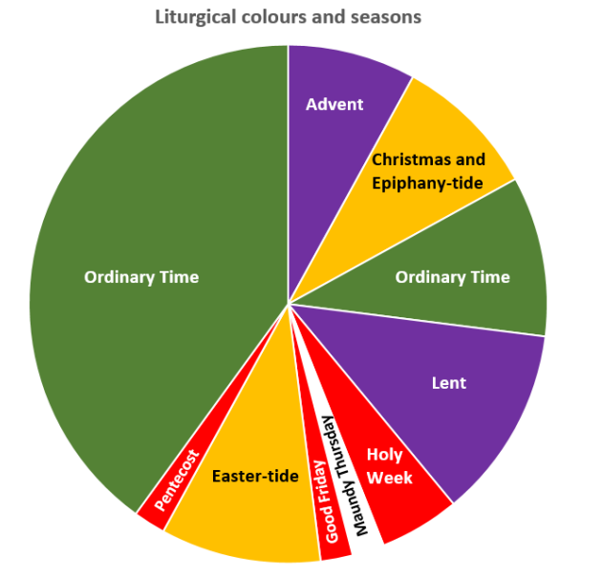

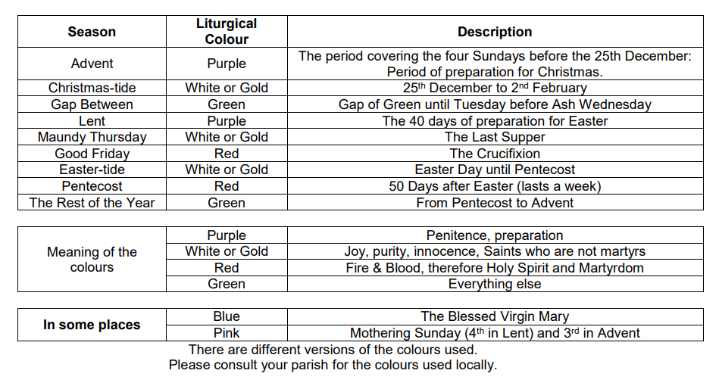

APPENDIX 2

Guidance for schools and academies on the right to withdrawal from Religious Education and Collective Worship March 2017
Collective Worship
The 1944 Education Act gave the right to withdraw from RE or collective worship to parents who wished their children to receive different form of RE or worship. This right is also confirmed in section 71 of the School Standards and Framework Act 1998. In the case of collective worship, the government guidance document is Circular 1/94: Religious Education and Collective Worship.

Collective worship in all Church of England schools and academies should honour the school’s trust deed and Christian foundations. Worship is central to school life, offering an opportunity for the whole school community to explore the distinctive beliefs and narrative that underpins the school’s Anglican foundations and distinctive Christian character. Worship is the responsibility of the governing body in conjunction with the headteacher, working in partnership with the staff and the local parish church.

Our Church of England schools should strive to ensure they are consistently excellent, distinctive, and inclusive, and that the whole curriculum is underpinned by Christian values. Religious Education is an important part of the curriculum in all Church of England schools and academies. Its nature, objectives, and content should be shared with parents each term to ensure that parents are able to recognise that RE is of educational value to all pupils, whatever their belief background. In the same way, collective worship should lie at the heart of school life, proclaiming its distinctive character and faith in a way that is relevant, inclusive and that leads each pupil a little further in their spiritual journey. In this way, the likelihood for parental requests for withdrawal should be reduced. However, when they are made they must be handled accordingly to the legal guidance, while there is scope for a little realism and adaptability in order to ensure the best for every pupil.

In many of our schools within the Diocese of Lichfield, there is a large percentage of children whose families are members of another faith. It is the purpose and duty of every church school to be distinctive as a Church of England school. In each school, it is part of the mission of the church to welcome those of other faiths and no faith. In most cases, parents will have chosen the school for their child, making a specific choice of the school because of the ethos and education it offers. In a small number of cases, parents of other faiths will have been offered a place at a church school because no other school has a place for their child within a reasonable catchment area.

The right to withdraw form collective worship should be at the instigation of the parents or pupils above the age of 16.

The right of withdrawal from collective worship
The right of withdrawal from collective worship would normally be exercised through the physical withdrawal of the pupil from the place where the act of worship is taking place. Indeed the school could insist that this is the way the right is to be implemented. If, however, both the parent and the school agree that the pupil should be allowed to remain physically present during the collective worship but not take part in it, nothing in the law prevents this.

Experience suggests that, to avoid misunderstanding, a Headteacher / Principal will find it helpful to establish with any parent wanting to exercise the right to withdrawal:
- the elements of worship in which the parent would object to the child taking part;

- the practical implications of withdrawal; and
- whether the parent will require any advanced notice of such worship, and, if so, how much.

Where parents have withdrawn their children form collective worship and request religious worship according to a particular faith or denomination, the governors and Headteacher / Principal will seek to respond positively to such requests providing:
- such arrangements can be made at no additional cost to the school; and
- that the alternative provision would be consistent with the overall purposes of the school curriculum as set out in Section 1 of the 1988 Education Act. (Circular 1/94)

