Year 5/6

Marvellous Mountains

Autumn Term 2

**Writing Text:**

Stormbreaker by Anthony Horowitz.

**PE:**

Tennis/Table tennis.

**Science:**

Engaging Science: light

We will be looking at how light travels and how the eyes see.

**PHSE:**

Myself and my relationships.

Class 4 will consider what bullying is and the impact that it has as well as what to do about bullying.

**Spanish:**

Festivals

Including Christmas.

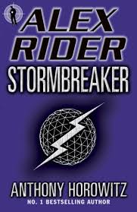

**Curriculum Enhancements**

Visit to a copper mine in Oswestry.

Visit to the theatre.

Class Book:

Stormbreaker by Anthony Horowitz

**Writing Genres:**

Narrative: creating suspense.

Non-fiction:

Discussion text, instructional writing.

**Maths:**

Fractions

Multiplication and division

**RE:**

How do people express their faith through the arts?

**Music**

Living on a prayer unit

**Art**

In Spring 1

**History:**

In Spring 1

**Reading Text:** Stormbreaker

The Warlock’s Whiskers

Twas the Night before Christmas

On Your Bike

**Geography:**

Mountains We will cover the physical features of mountains and look at the seven highest summits in the world.

**DT**

Class 4 will design, plan, create and evaluate their own stuffed toys.