The Federation of St Lawrence CE and Tibberton CE Primary Schools

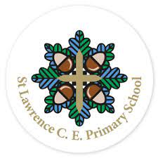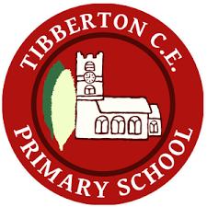

‘Being the best we can be with God’

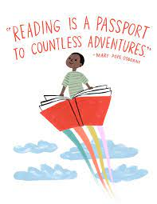

How to help your child read at home.

Intent- We believe that the teaching of reading is integral to a child’s understanding and appreciation of the world around them; a platform that allows our children to see beyond what they know, share in cultural experiences and develop the vocabulary they need to effectively express themselves. At the heart of our reading curriculum is our drive to foster a love of reading, enriching children’s learning through carefully designed teaching activities and access to thought provoking texts. Reading is at the heart of our curriculum, and we strongly believe it is the window to the world.

Implementation- Learning to read is one of the most important things your child will ever learn. It underpins everything else, so we put as much energy as we possibly can into making sure that every single child learns to read as quickly as possible. We also want your child to develop a real love of reading and for them to want to read for themselves. This is why we work hard to make sure children develop a love of books as well as simply learning to read.
As children begin their reading journey, the reading curriculum is delivered through Little Wandle phonics as a vehicle for word reading. This is rolled out into Key Stage 2 as an intervention for those children who are not secure with some of the more complex sounds taught.
Opportunities for independent reading and hearing quality texts read aloud every day are integral to our curriculum. We work with children to develop their understanding of texts through guided reading and whole class comprehension activities and have recently introduced Reading Vipers to focus on the key areas of comprehension.

Reading Vipers
Reading Vipers is a way of supporting children with their reading comprehension skills using the six domains of reading. All children will be working on VIPERS during class reading, whether it is reading as a class, in a small group, or one-to-one with an adult. It would be fantastic if parents could also be referring to VIPERS when they listen to their child read at home. Each of the letters stand for one of the key reading skills that will enable our pupils to become strong, confident readers. You will find a VIPERS bookmark in your child’s reading diary that will give you some examples of the types of questions to ask when your child is reading their book.
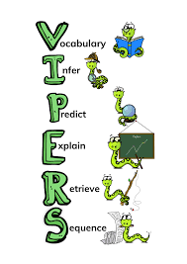
Question Openers
VIPERS can be used on any text that a child is reading, as well as on pictures, picture books and films. When any adult is listening to a child read, all they have to do is think of questions about the book, picture or film that cover all of the VIPERS. You can use the Vipers bookmark attached to your child’s reading record for examples of questions. Below are examples of how you can create your own questions.
How to use VIPERS questions with a page of a picture book:

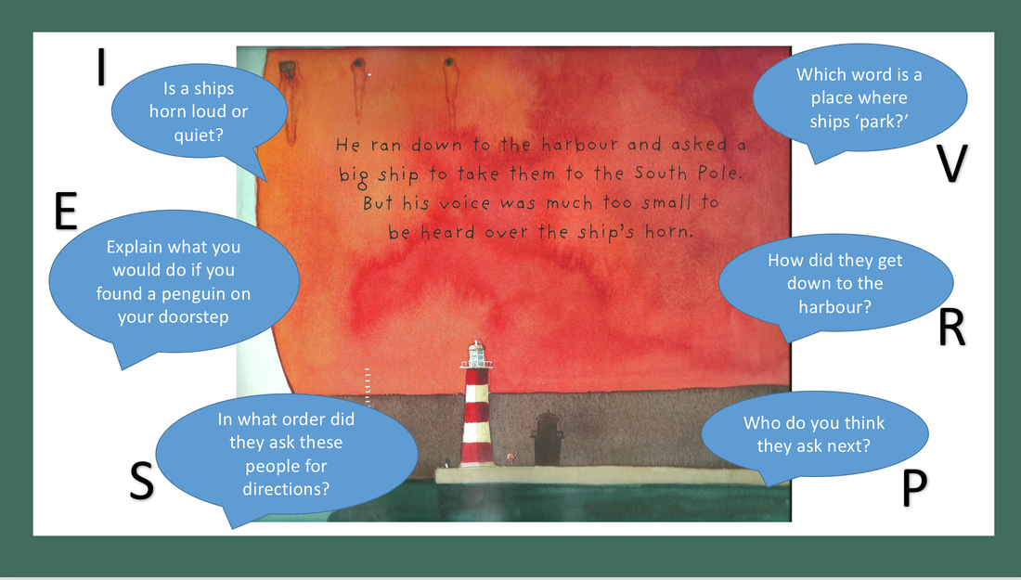

Helping your child at home
You, as role model in your child’s life, play a vital part in developing your child’s attitude in reading. To improve your child’s chances of becoming a keen and confident reader, you must demonstrate an enthusiasm towards reading and encourage your child to take an interest in print around them.:
- On packaging, labels and instructions;
- On information boards and menus;
- Comics, websites, magazines, newspapers, recipe books, birthday cards, and even shopping lists!

Reading should be enjoyed. Find a comfortable place to read, be patient and praise often.
Make reading a daily routine- aim for 10-15 minutes a day.
Read to your child, modelling to them how an expert reads.
Remember praise is a great motivator! Always remind your child how well they are doing and how proud you are of their reading.

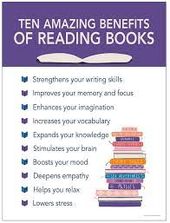

The ability to read fluently and with comprehension (understanding) is the most fundamental skill that children will learn. Children will first need to ‘learn to read’ in order to be able to ‘read to learn’.
- Discuss the text (book talk)
New book- look at the cover, what is it about, who is the author, what is the title, what type of book is it?
Partially read book- what have you liked so far? In 5 sentences, explain to me what has happened, who is the main character etc.
- Listen to your child read
You can: praise and encourage often; check understanding of unfamiliar words and explicitly teach new vocabulary; encourage them to improve accuracy and expression; model reading with expression and ask your child to copy; ask questions to check for understanding.
They can: sound out unfamiliar words in chunks and then blend them; use pictures as clues to unfamiliar words, or infer more information about the text.

