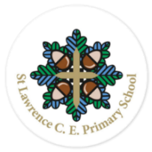

**Mind*talk***

**TIBBERTON & St LAWRENCE CE PRIMARY SCHOOLS**

Be Kind To Your Mind **Autumn Edition**

