
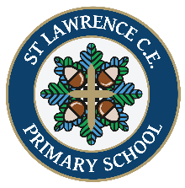
Mindtalk
TIBBERTON & St LAWRENCE CE PRIMARY SCHOOLS
Be Kind To Your Mind Autumn Edition

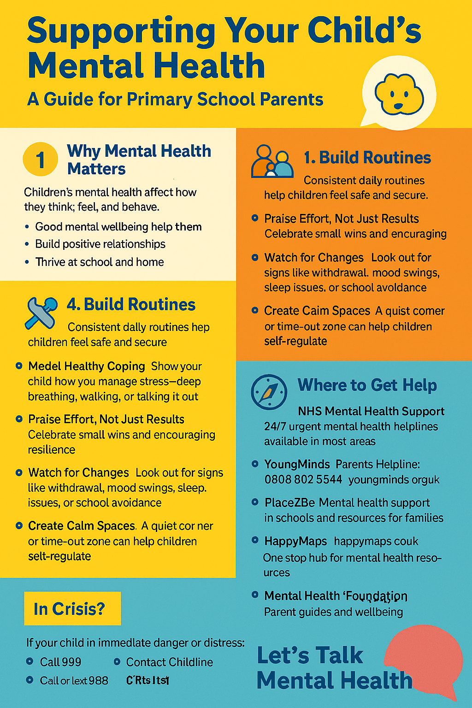
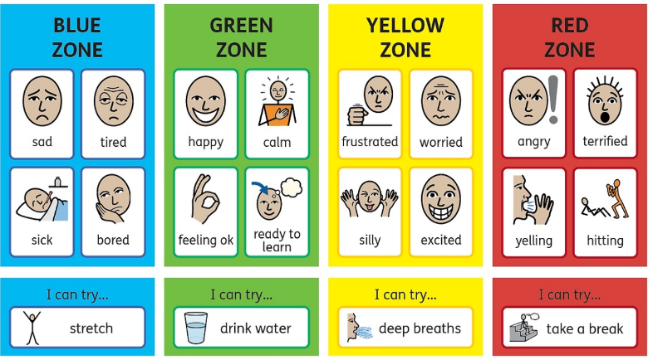
How Zones of Regulation supports children’s mental health in our school.
Across school, we use Zones of Regulation to support children to understand their emotions and recognise how they feel. The zones reinforces that all emotions are valid and part of being human—what matters is how we manage them, and we can teach children self-regulation strategies. Importantly, it also encourages children to recognise how others might be feeling and to respond appropriately. Parent workshops will be held in the autumn term for those who wish to understand more.
Wellbeing Charter Mark
Over the past year, our schools have proudly taken part in the Wellbeing Charter Mark, reflecting our strong commitment to social, emotional, and mental health (SEMH). Through this initiative, we’ve introduced a range of positive changes aimed at enhancing mental wellbeing for our pupils, staff, and families. It’s been a meaningful journey, and we’re excited to continue building a nurturing and supportive environment for everyone in our school community.
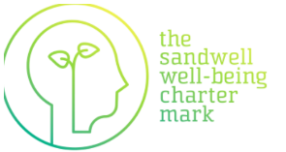
Mental health support in school
Learning and understanding mental health is embedded across our curriculum and taught in all year groups. Sometimes, children need additional support in school and/or with outside agencies. Mrs Osborne is our senior mental health lead and mental health first aider. Mrs Booth and Mrs Leon are our ELSAs and Mrs Osborne is trained in Drawing and Talking therapy.
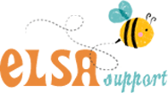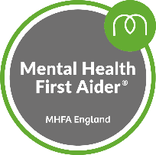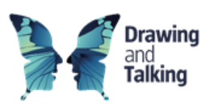

Friday 10th October is World Mental Health Day. During the week, we have parent coffee mornings with a mental health focus, additional learning and activities in class around mental health and Wear It Yellow to raise awareness and show support for mental health.

